
SHRI RAMSWAROOP MEMORIAL
UNIVERSITY



BANKING DATA ANALYSIS
PROJECT

Group Members – Syed Mohd Raza Rizvi, Arman Rizvi
Roll no. – 202410101150086 , 202410101150076
Group – 33rd
Subject – Data Analytics & Reporting
Submitted to – Mrs. Deepika Tiwari

BANKING DATA ANALYSIS

Objective
To analyze, clean, and visualize banking data using Microsoft Excel and Python (Pandas and Matplotlib) for identifying key insights and trends.

Outcomes
- Improved data quality by handling missing and duplicate values.
- Gained understanding of customer balances and account trends.
- Created organized data views using pivot tables and summary charts.
- Compared Excel-based and Python-based analysis approaches.

Required Tools
- Microsoft Excel (for manual data operations and pivot charts)
- Python (Pandas, Matplotlib) (for automated data analysis and visualization)

WORKING

Part A: Data Analysis using Microsoft Excel
Step 1: Importing and Understanding the Data - The dataset Banking_Data02.xlsx was opened in Excel. - Initial rows were reviewed to understand columns like Customer ID, Gender, Account Type, Balance, Annual Income, etc. - Checked overall data size and structure.

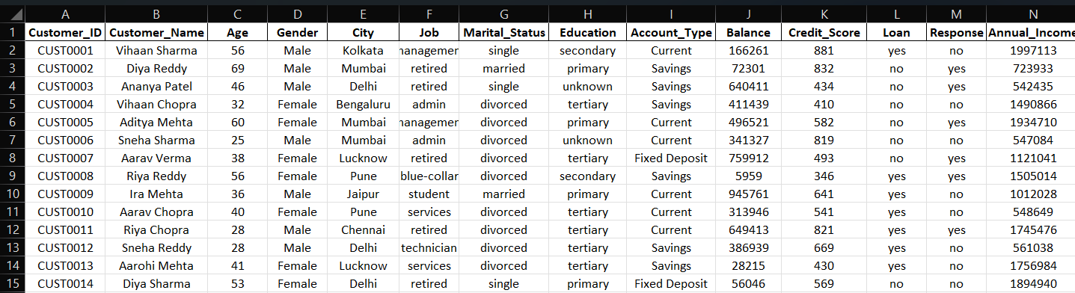

Step 2: Handling Missing Values - Used Excel filters to identify any blank or missing cells. Filling blank with na - Filled missing categorical values (like Gender) using most frequent entries. - Replaced missing numeric values (like Balance) using average values.
Highlighting the Blank value
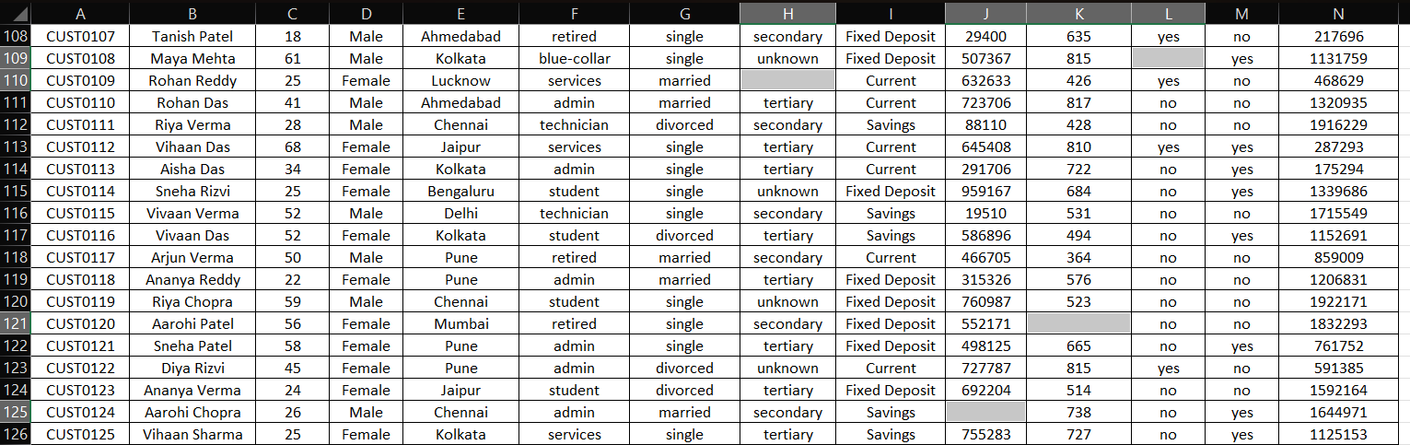
Filling Blanks With na
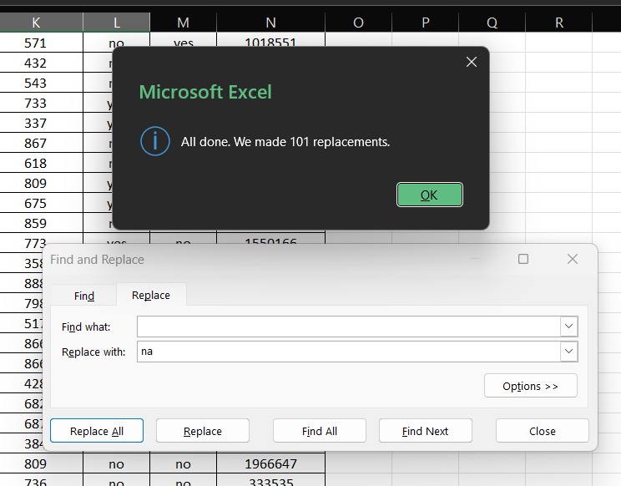

Replacing na with particular Column Average value

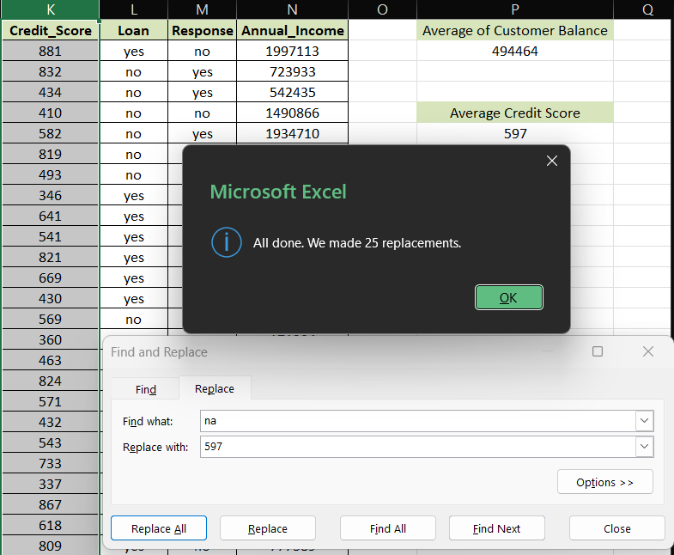
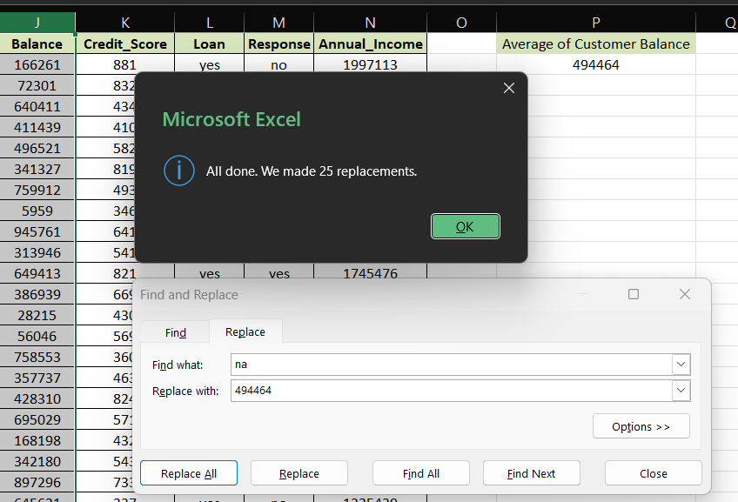

Step 3: Removing Duplicates and Formatting - Used the Remove Duplicates feature in Excel under Data Tools. - Applied conditional formatting to highlight balances above a certain limit
Highlighting the duplicates
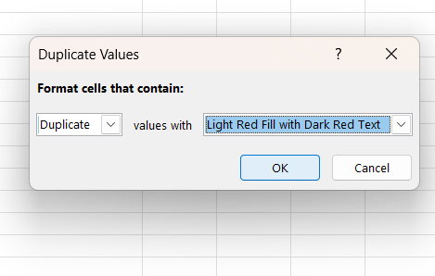

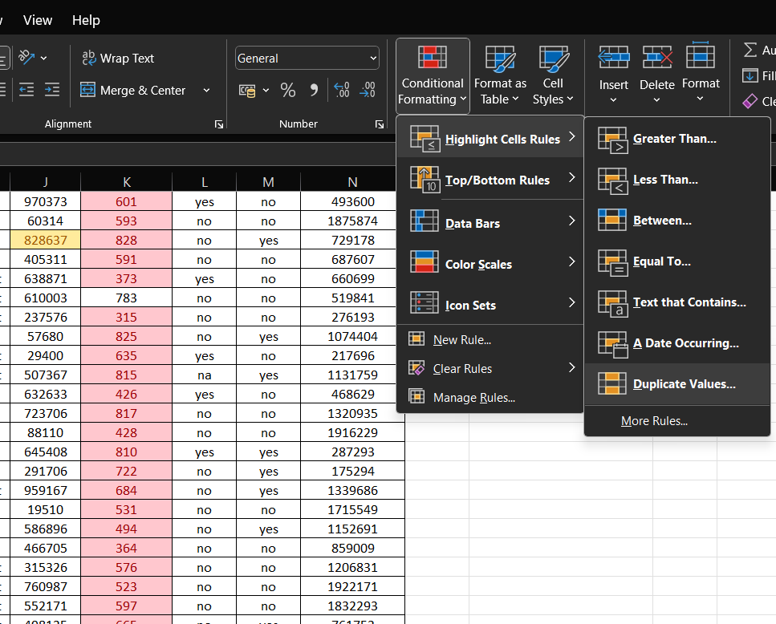

Step 4 - filtering numeric data in Excel to display only those rows whose values fall within a specified range using the Number Filter → Between option.
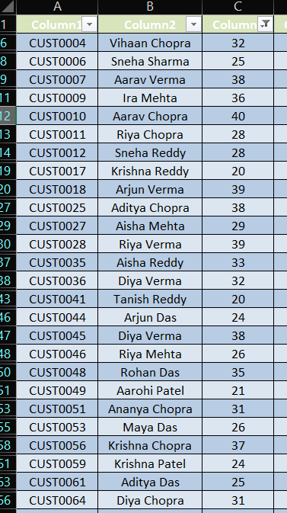
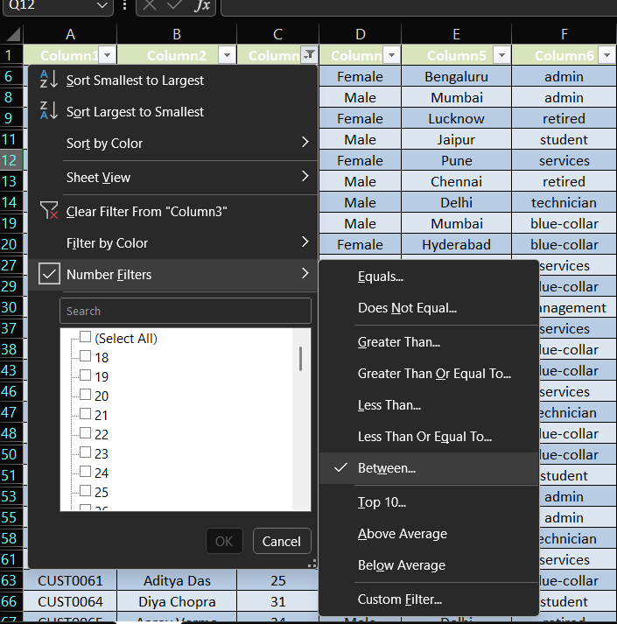

Step 4: Pivot Tables and Charts - Created Pivot Tables to summarize data by Account Type and Gender. - Used Pivot Charts to visualize trends in customer balances.

Sum of Annual Income by City Count of Customer Id by city
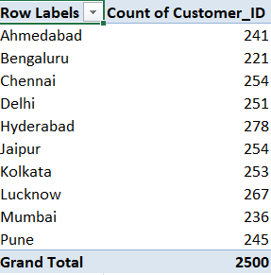
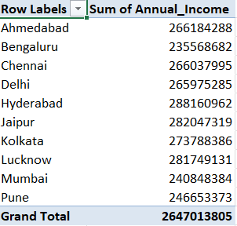

Count of Customers Id And Their Balance Sum of Annual Income According to
According to their Status Bank Type
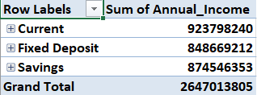
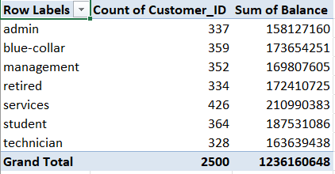

Sum of Annual Income According to customer
Name Martial status , education and City.

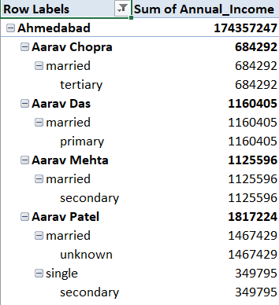

Step 5: Creating Different types of Chart according to the pivot table

Sum of Annual Income by City
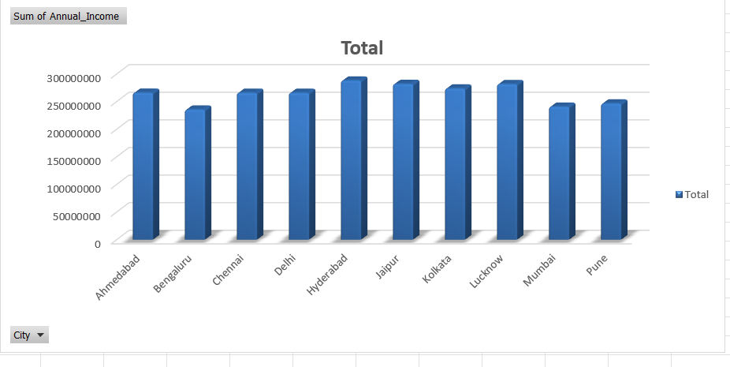

Count of Customer Id by city
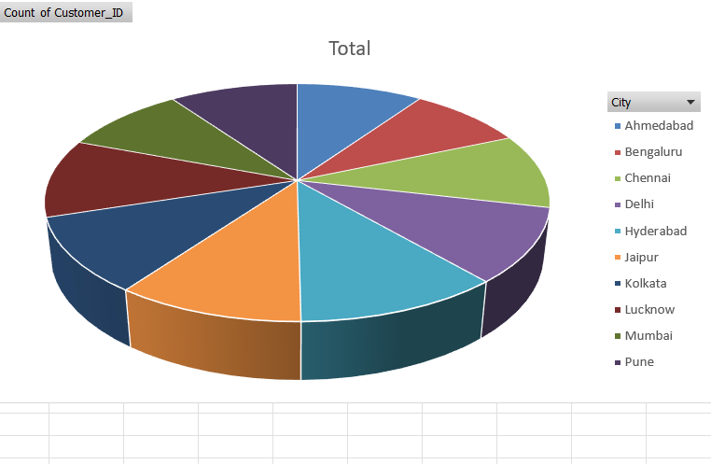

Count of Customers Id And Their Balance according to their Job status
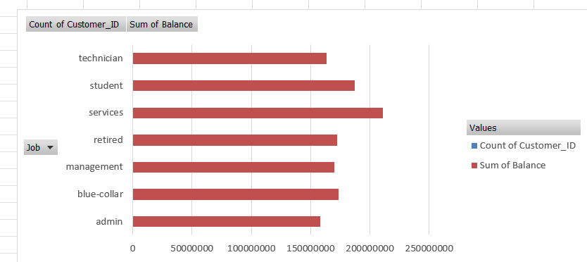
Sum of Annual Income According to customer Name
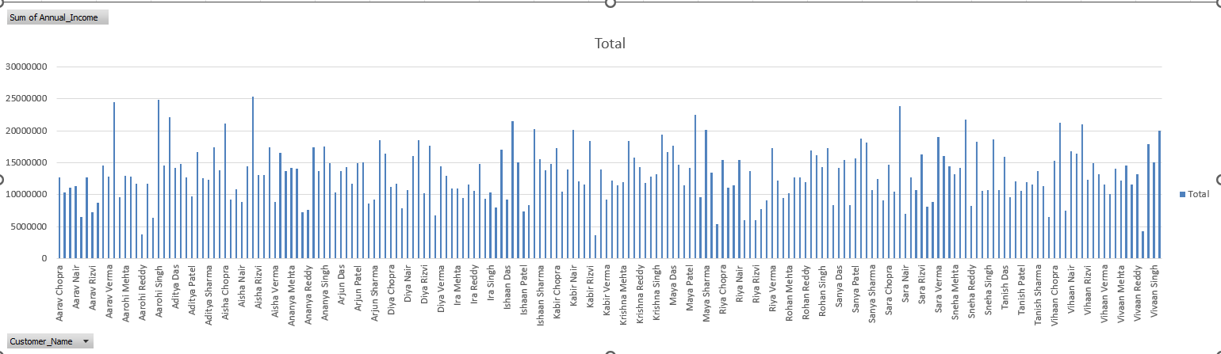

Part B: Data Analysis using Python (Pandas + Matplotlib)
Step 1: Importing Data - The Excel sheet was loaded into a Pandas DataFrame using pd.read_excel(). - Displayed the first five rows using .head().

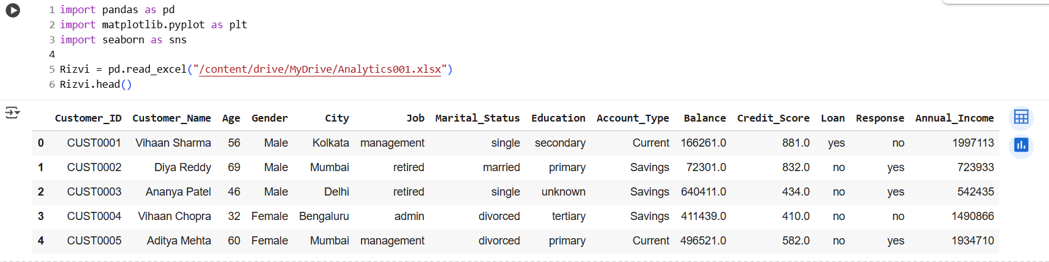

Step 2: Data Structure Overview - Checked total rows and columns using .shape.

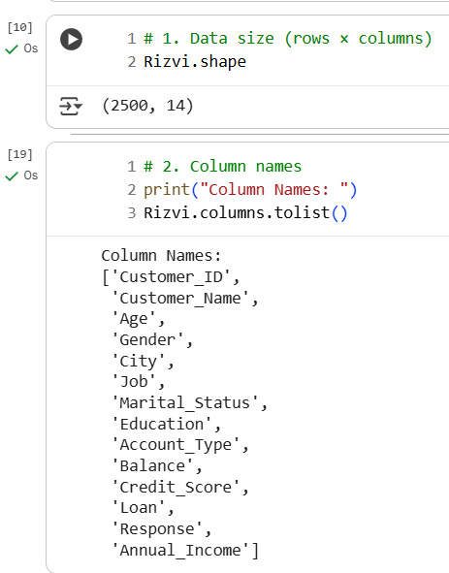

Printed column names using .columns.tolist()

Analyzing Every information about the data like data type and data size in bytes

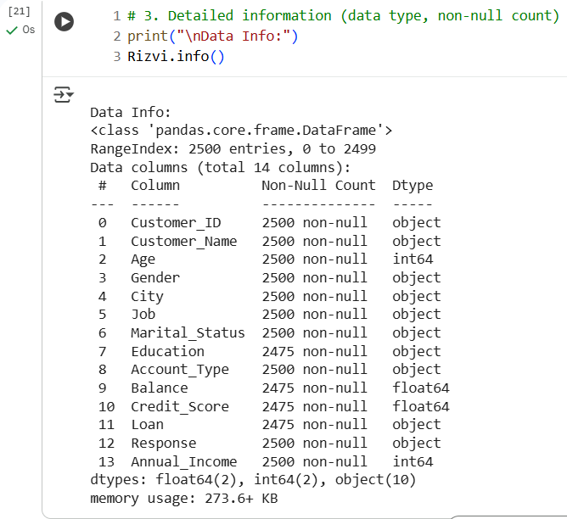

Used .info() .describe() to understand summary statistics.
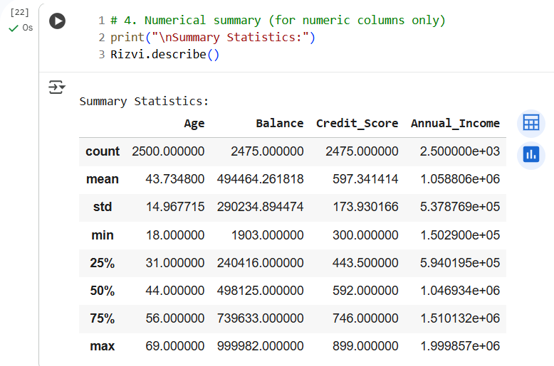

Checking that any Missing value is exist or not (True or False)

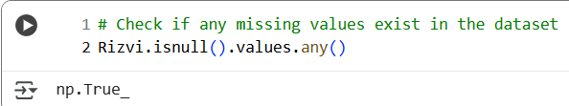

Step 3: Handling Missing and Duplicate Values - Verified missing values using .isnull().sum().
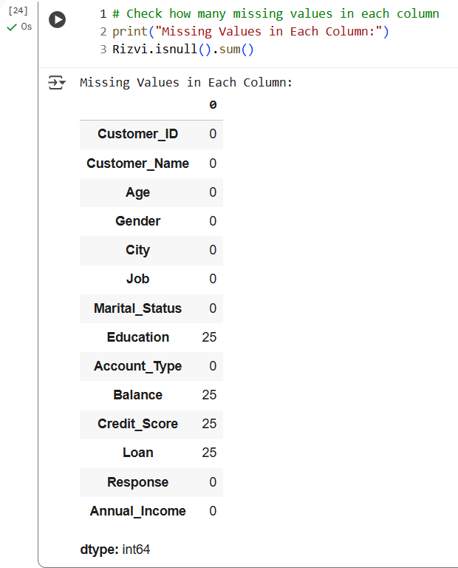
Filled missing categorical and numeric values using mode and mean respectively.
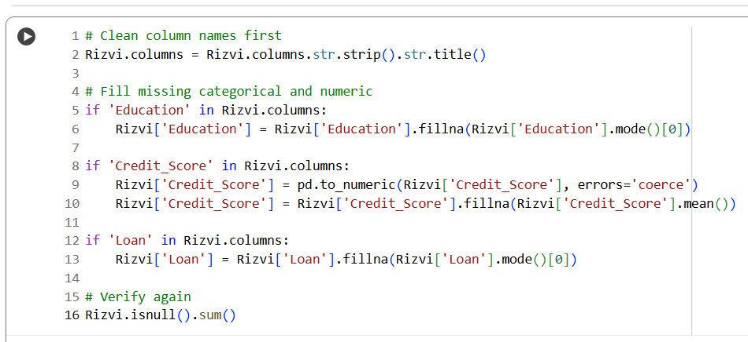

Removed duplicates using .drop_duplicates().

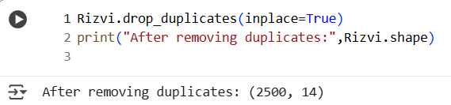

Step 4: Sorting and Filtering Data - Sorted the dataset by Balance in descending order.

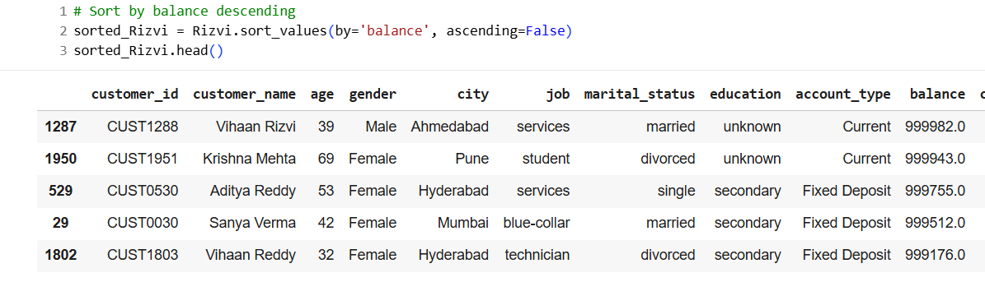

Filtered customers with balances greater than 500,000.
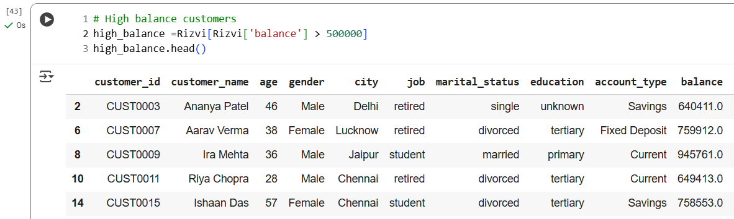

Calculated average balance grouped by Account Type using .groupby().
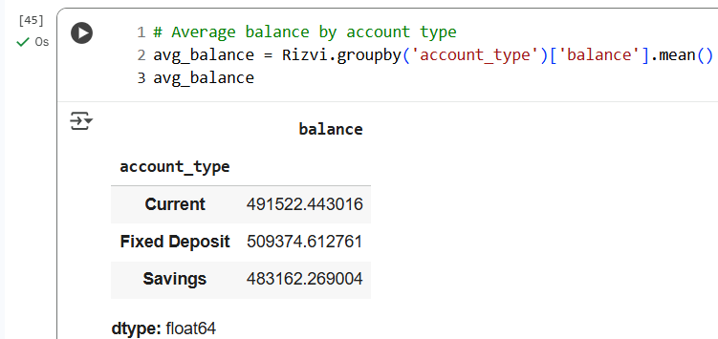

Step 5: Data Visualization - Creating bar plot of Customer name according to the gender male or female
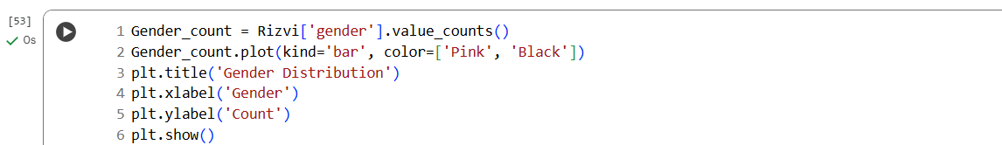
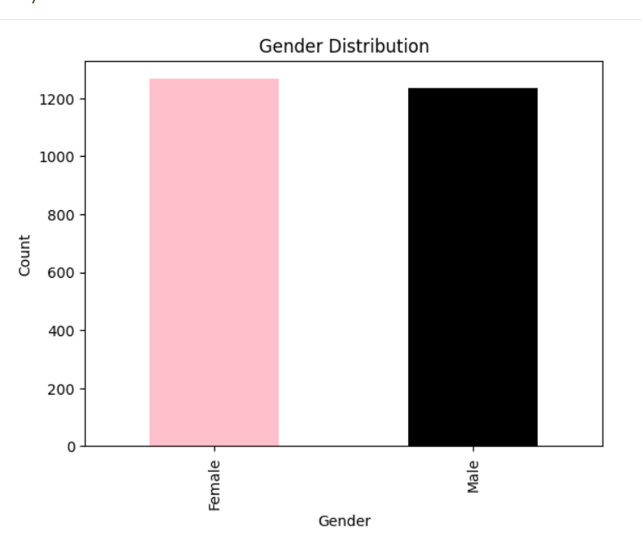

Creating the Bar Plot of Average balance by account type

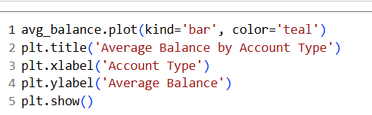

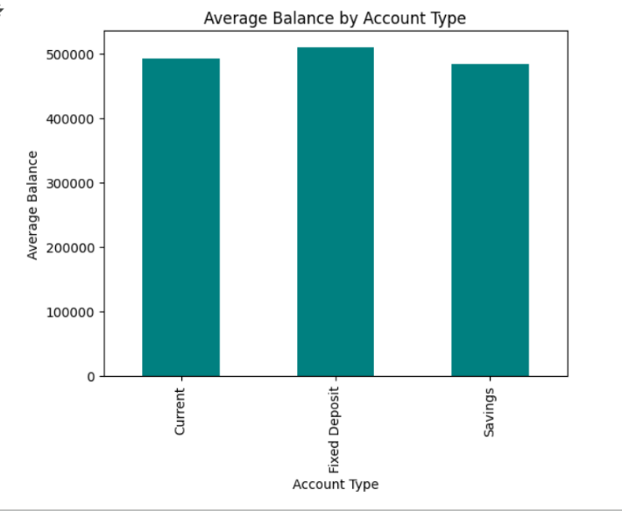

Creating a Histogram for Balance x Frequency , Balance Contribution for Data Visualization

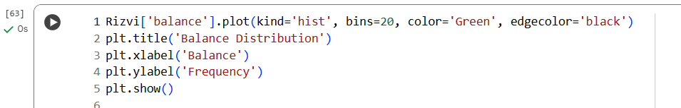

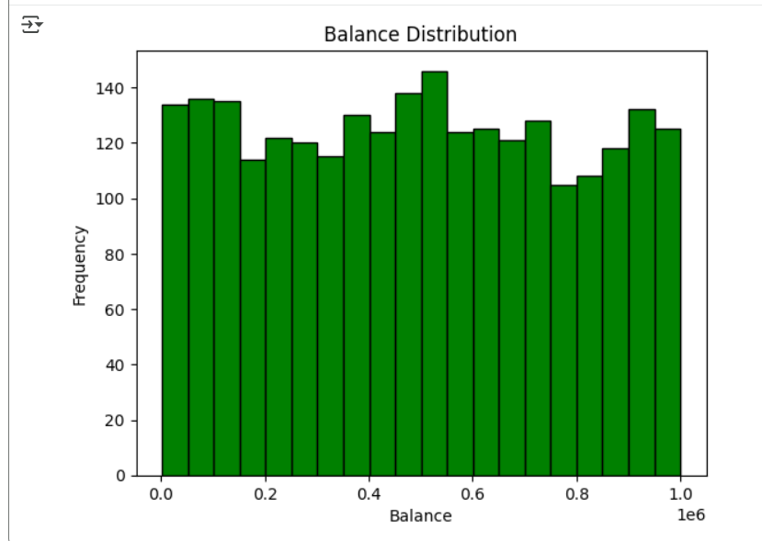

Conclusion
Both Excel and Pandas were effectively used to clean, analyze, and visualize the banking dataset. Excel allowed quick visual insights using built-in tools, while Pandas provided flexibility and automation for deeper analysis. The overall analysis improved data quality and highlighted financial patterns across different customer segments.

